SIMATS ENGINEERING
CO3- AT2 - Design Task - Medium

COURSE NAME: Advance Wireless Communication Systems /
5G / 6G Communication Systems
COURSE CODE: ECA5604 Slot-A

COURSE OUTCOME COVERED
CO: 3 - Design spectrum access strategies, waveform generation methods, and
multiple access techniques for efficient wireless transmission systems. (BL6)
Assessment Tool Number : CO3_AT2
Assessment Tool Weightage : 35%
Assessment Tool : Design Task
Duration : 180 Minutes
Marks : 100 Marks
Type of Assessment Conduction : At Home
Evaluation Type : GitHub
Result Generation : Students design and justify appropriate wireless
communication solutions by applying engineering
principles to meet specified requirements.
Topic Covered :
Spectrum management, licensed/unlicensed spectrum, dynamic spectrum access,
cognitive radio, OFDMA, resource block allocation, GFDMA, NOMA, power- domain
multiplexing, SIC, and IoT applications. Advanced waveforms and wireless
technologies including GFDM, FBMC, UFMC, mmWave propagation, path loss and
penetration, millimeter-wave antenna systems, MIMO, and Massive MIMO
fundamentals.
Short description about assessment: Students design a system / model based on
given requirements to assess creativity and application skills. This question paper
consists of a total of 40 questions, out of which each student is required to answer any
2 questions. Each question carries 50 marks, and the paper carries a total of 100
Marks

QUESTIONS: 2 (2 X 50 = 100) Total Marks: 100 Duration: 3hrs
- Design a low-power communication model for battery-operated IoT devices. (BL6)
- Design an NB-IoT architecture for smart utility monitoring. (BL6)

Code of Conduct:
I __Velamuri Bhanodhay (192412330)___ (Name / Reg No) certify that this submission is my original work and that I have adhered to the guidelines specified for this assessment. I understand that any violation of academic integrity rules will result in disciplinary action.
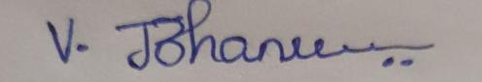
Signature of the student:

RUBRICS FOR CALCULATION:

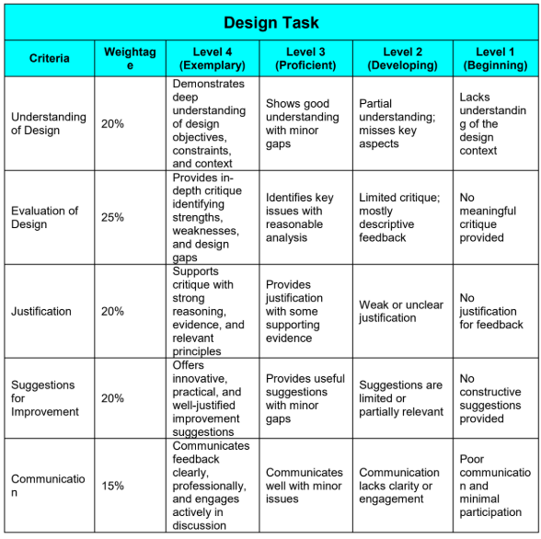
Design Task
Course Code & Title: | ECA5604 -5G/6G COMMUNICATION | Course Faculty: | Dr.K.Sathish
Student Name: | Velamuri Bhanodhay | Reg. No.: | 192412330
Dept / Batch: | BE.ECE / 2024 | Date: | 10/8/2026

- Design a low-power communication model for battery-operated IoT devices.
Idea: Use sleep mode + short data packets + low transmission power to reduce battery consumption.
Program Code:-
clc; clear; close all;
% IoT communication parameters
N = 100; % Number of transmissions
Ptx = 20; % TX power (mW)
Psleep = 0.1; % Sleep power (mW)
Ttx = 0.01; % Transmission time (s)
Tframe = 1; % Frame duration (s)
% Energy consumed per frame
Etx = Ptx*Ttx;
Esleep = Psleep*(Tframe-Ttx);
Eframe = Etx + Esleep;
% Total energy
Etotal = N*Eframe;
fprintf('Energy per frame = %.3f mJ\n',Eframe);
fprintf('Total energy = %.3f mJ\n',Etotal);
% Compare with always-active communication
Eactive = N*Ptx*Tframe;
fprintf('Always-active energy = %.3f mJ\n',Eactive);
% Energy saving
saving = (1-Etotal/Eactive)*100;
fprintf('Energy saving = %.2f %%\n',saving);
% Plot
bar([Etotal Eactive])
set(gca,'XTickLabel',{'Low-Power IoT','Always Active'})
ylabel('Energy (mJ)')
title('Energy Consumption Comparison')
grid on

Design block diagram
Sensor → ESP32/IoT Node → Low-Power Transmitter → Gateway/Cloud
with:
Sleep → Sense → Transmit → Sleep
Conclusion:
The proposed model improves battery life by minimizing active transmission time and keeping the IoT device in sleep mode whenever communication is not required.
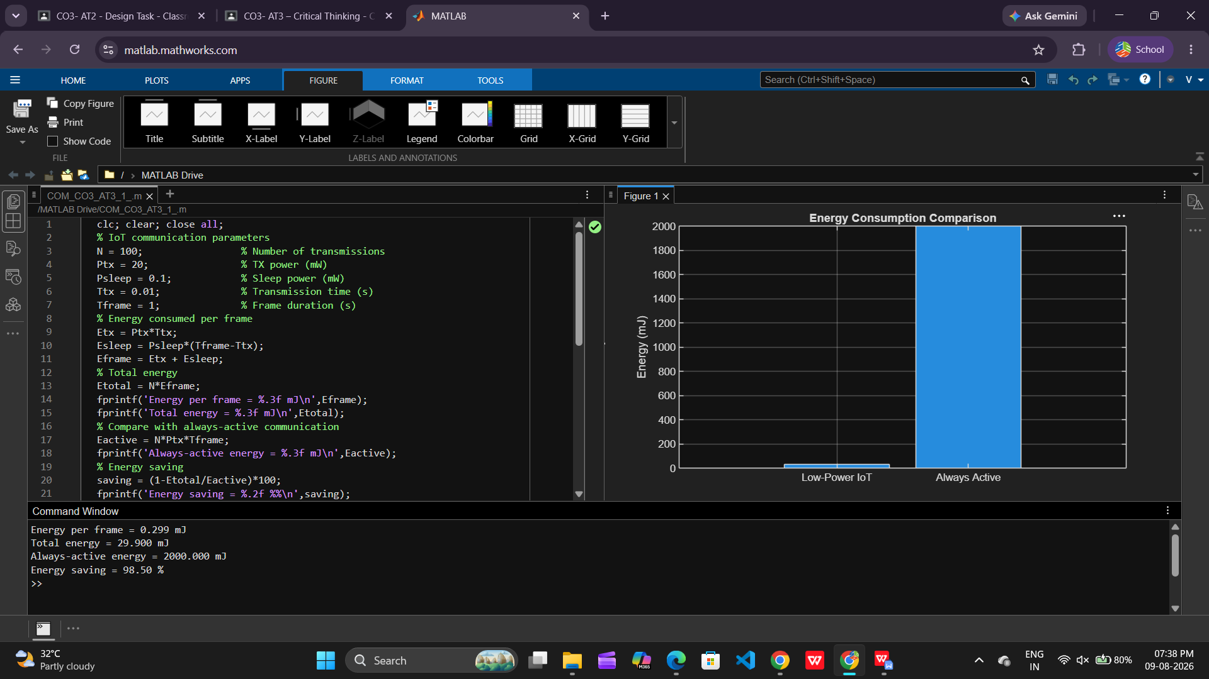

- Design an NB-IoT architecture for smart utility monitoring.
Architecture: Smart Meter → NB-IoT UE → eNB → EPC → IoT Cloud → Utility Monitoring Center
Program Code:-
clc; clear; close all;
% Smart utility monitoring using NB-IoT
N = 10; % Number of smart meters
data = randi([1 100],1,N); % Utility readings
Ptx = 200; % Transmit power (mW)
Ttx = 0.02; % Transmission time (s)
% Energy used for transmitting each reading
E = Ptx*Ttx;
TotalEnergy = N*E;
fprintf('Number of meters = %d\n',N);
fprintf('Energy per reading = %.2f mJ\n',E);
fprintf('Total energy = %.2f mJ\n',TotalEnergy);
% Display utility readings
figure;
stem(1:N,data,'filled');
xlabel('Smart Meter');
ylabel('Utility Reading');
title('NB-IoT Smart Utility Monitoring');
grid on;

MATLAB Design Output
The program calculates:
- Energy per meter reading
- Total transmission energy
- Utility readings of 10 smart meters
- Graph of monitored utility consumption

Key Design Features
Feature | NB-IoT Design
Device | Smart meter
Access | NB-IoT
Network | eNB + EPC
Application | Utility monitoring
Power | Low
Coverage | Wide
Data | Small periodic packets
Conclusion:
The proposed NB-IoT architecture enables low-power, wide-area and reliable smart utility monitoring, making it suitable for electricity, water and gas meters.

